Practical Test Applied Information Technology

1. Use your graphics package to create the following:

(a)

Auto shapes align bottoms

Number use word art and rotate

(b)

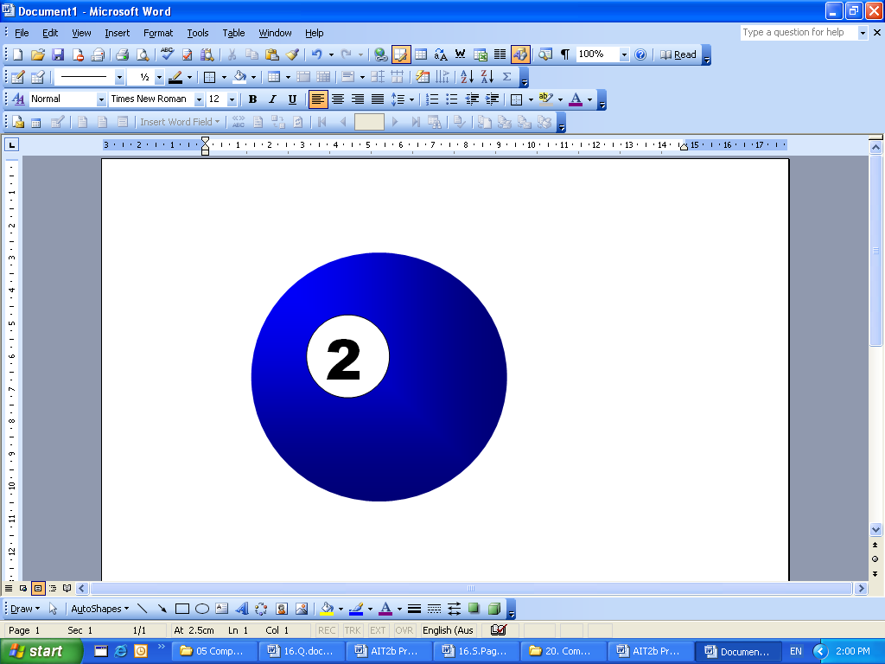

Circle gradient fill from corner blue

Circle for number remove line

Number in text box no line no fill

(c)
Corel Draw graph paper
12 x 10 fill in boxes

A
B
C
D
E
 | 1 |  | 2 |  | 3 |  | 4 |  | 5 |  | 6

A
B
C
D
E
 | 1 |  | 2 |  | 3 |  | 4 |  | 5 |  | 6
2.
Use the file elephant.bmp
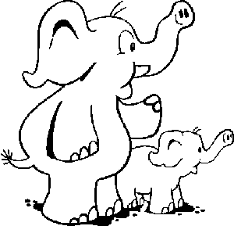

Save this file as XXELE.bmp, replacing XX with your initials. Now make the following changes to image:
- Colour the small elephant pink
- Colour the large elephant green
- Colour all their toenails red
- Make the large elephants tusk blue
- Add blue spots all over the small elephant
- Add another small elephant exactly the same as the existing
one on the left side of the large elephant.
- Remove the trunk from the original small elephant.
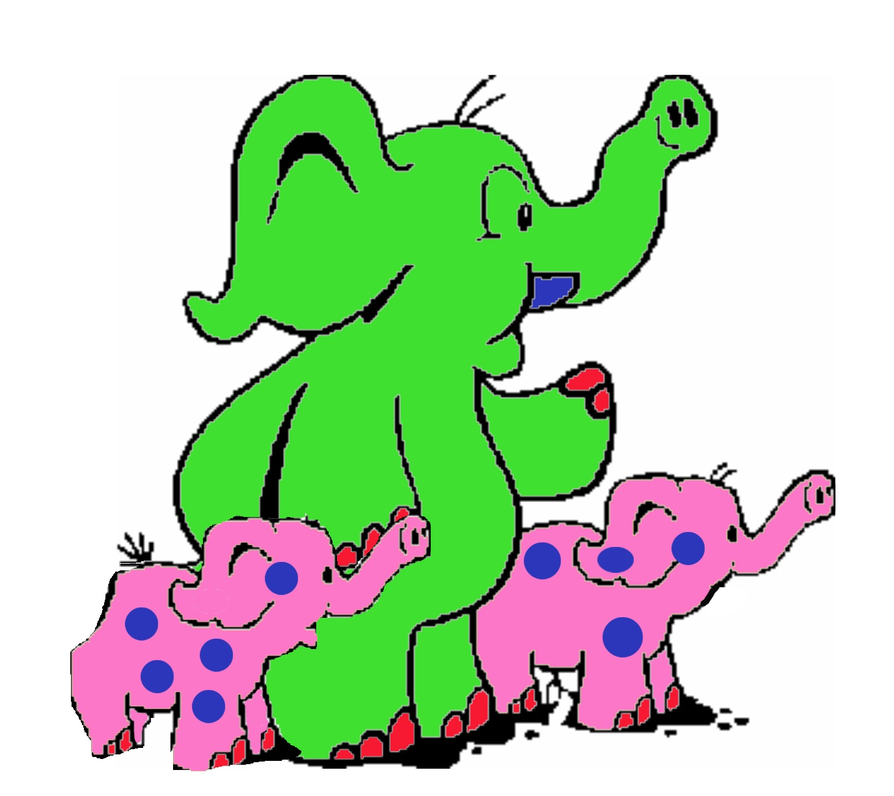
3. Use your graphics package to create a poster advertising a ‘limited collector plate’ according to the following minimum specifications:

Save this file as XXPLATE, replacing XX with your initials.

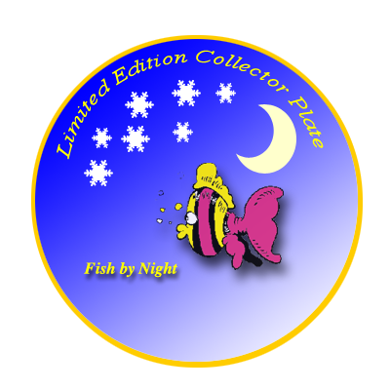
- The size of image is 400 by 400 pixels, with the plate centred as shown
- The following text must appear on the poster
“Limited Edition Collector Plate - Fish by Night ”
- The plate is shaded with a gradient fill and will give the effect of a star filled evening sky
- The edge of the plate is gold
- At the top of the plate is a graphic of the moon, created by you.
In the centre of the plate is the graphic, FISHY.JPG, which is shown below.

(f) Colour this fish in your school colours and
give the fish a shadow.

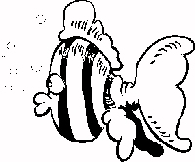
Fish Plate
Moon

Olympic Advert

In the lead up to the Olympics a local newspaper is running a competition offering its readers the chance to compete in a race at the official Olympic venue against some great Aussie legends.

Your task is to create a newspaper advertisement like the one on the next page. Make sure that you adhere to the following guidelines:

- The advertisement is 20cm wide and 10cm high.
- The title ‘run against Aussie legends’ is white on black.
- The graphic (bottom left corner) should be any appropriate graphic/clipart.
- The text below the title should wrap around the graphic.
- The question should be in bold.
- The fill-in coupon should have a border as shown.
- The newspapers address should be in bold.
- The layout of the advertisement should be as in the sample.
- Add your name in the bottom right hand corner of the advertisement.
- Spell check your document.
- Save your work as XXADVERT, replacing XX with your initials and print.

Save as: your name olympic.doc to a folder title AIT2b Marking created by you in the AIT 2b Folder.

